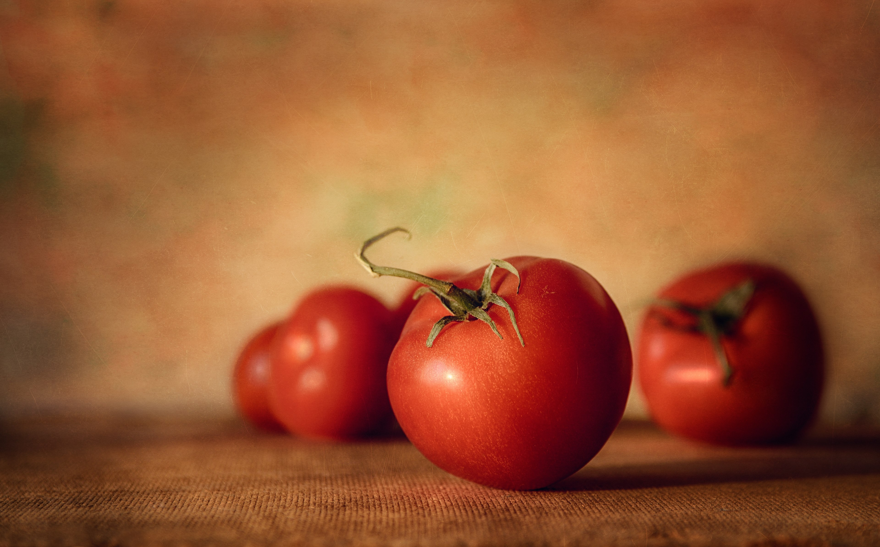

Hello World!

**Does it amke any difference**? For last few days I was thinking about two different and opposite scenarios of the world. Actually its in the wake of Aurat Azadi March. Let's assume there are two men Mr C and Mr R. Mr C is a conservative type and Mr R is a liberal type. Both of them have different approaches to life. Mr C thinks that the women or especially his wife (when he says woman, it comes in his mind that he is talking about his wife instead of his mother, sister or daughter) are not allowed to live their lives according to their free will. They are bound to follow the wills of their men, who are their proctector and bread winners as well. The women do not have any right to think as equal as a man or even demand equal rights as of a man. Even these women are not allowed to wear what they want to wear but they must wear what society will tell them to wear. However a man can do anything he wants. He has a free will. He has control (daraja) over a woman.

On the other hand Mr R thinks that man and woman are equal. The only difference is biological that the way God has created both of them in different way. Otherwise man and woman are equal in each and every aspect of life. They can live according to their own free will. It is understood that they are mature. They know what is right and what is wrong. They can choose what is good for them. A woman needs no man to tell her that what is right or wrong. She is for sure responsible for her actions and her words. A man should not feel shame for words or acitons of a woman.



Sway provides an engaging way to showcase your photography, art, or design portfolio. Add your multimedia content, organize it, and you're almost done! Add words where you'd like to provide more context. Emphasize the most important images to focus the reader's attention.

Sway's design engine takes the hard work out of formatting your content by producing professional designs in minutes, auto-aligning and cropping content as needed. Try changing the look and feel of your Sway by clicking on the **Design** tab in the top toolbar. To change the overall layout of your Sway choose a different option.

Sway offers a variety of ways to present your content.  The images below are grouped into a grid, which automatically organizes any images, videos and text in the Grid card into a uniform grid layout.  Click on **Group Type** on this Group card to try out other options.  Tap an image and select **Focus Points** and then tap to add one or more focus points. These points tell Sway which parts of your image are most important to preserve while it applies intelligent cropping.

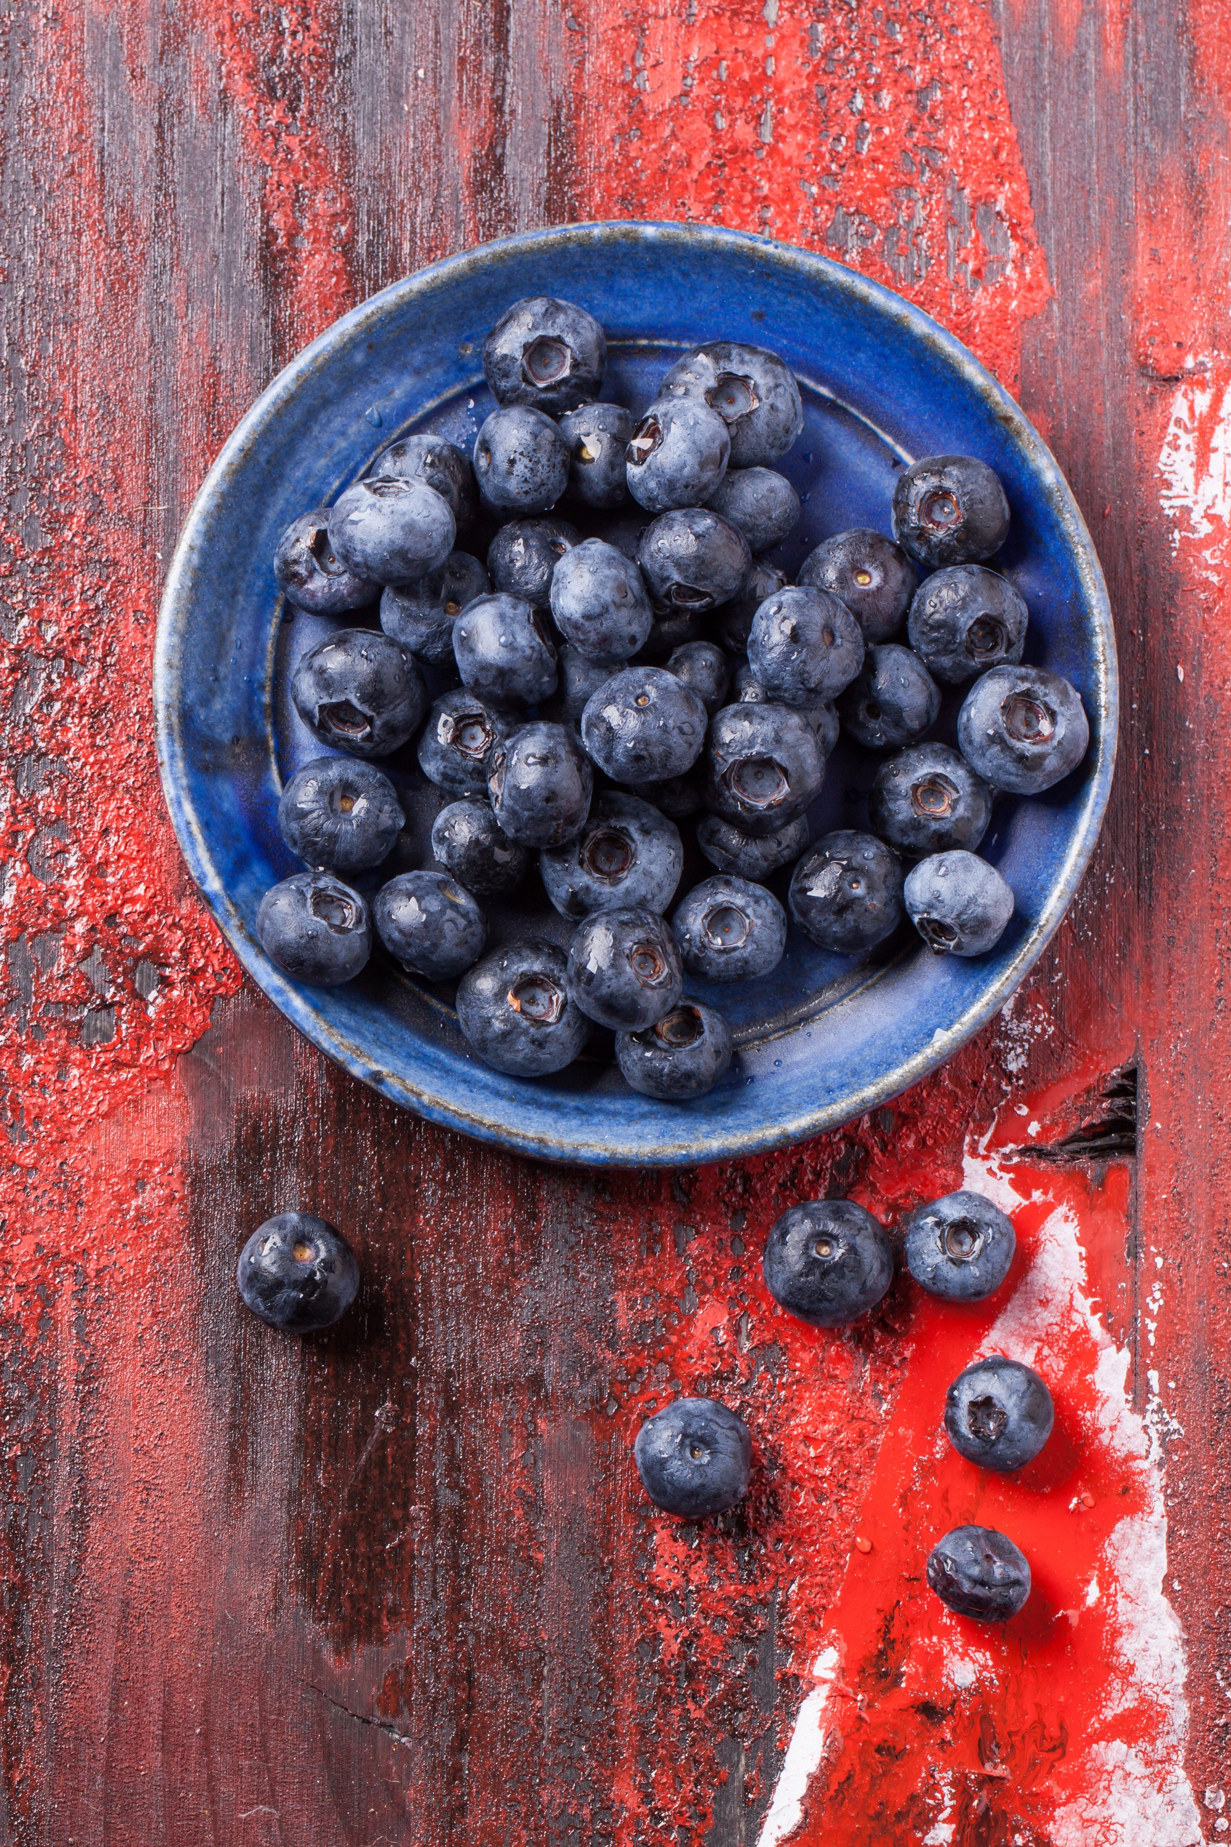

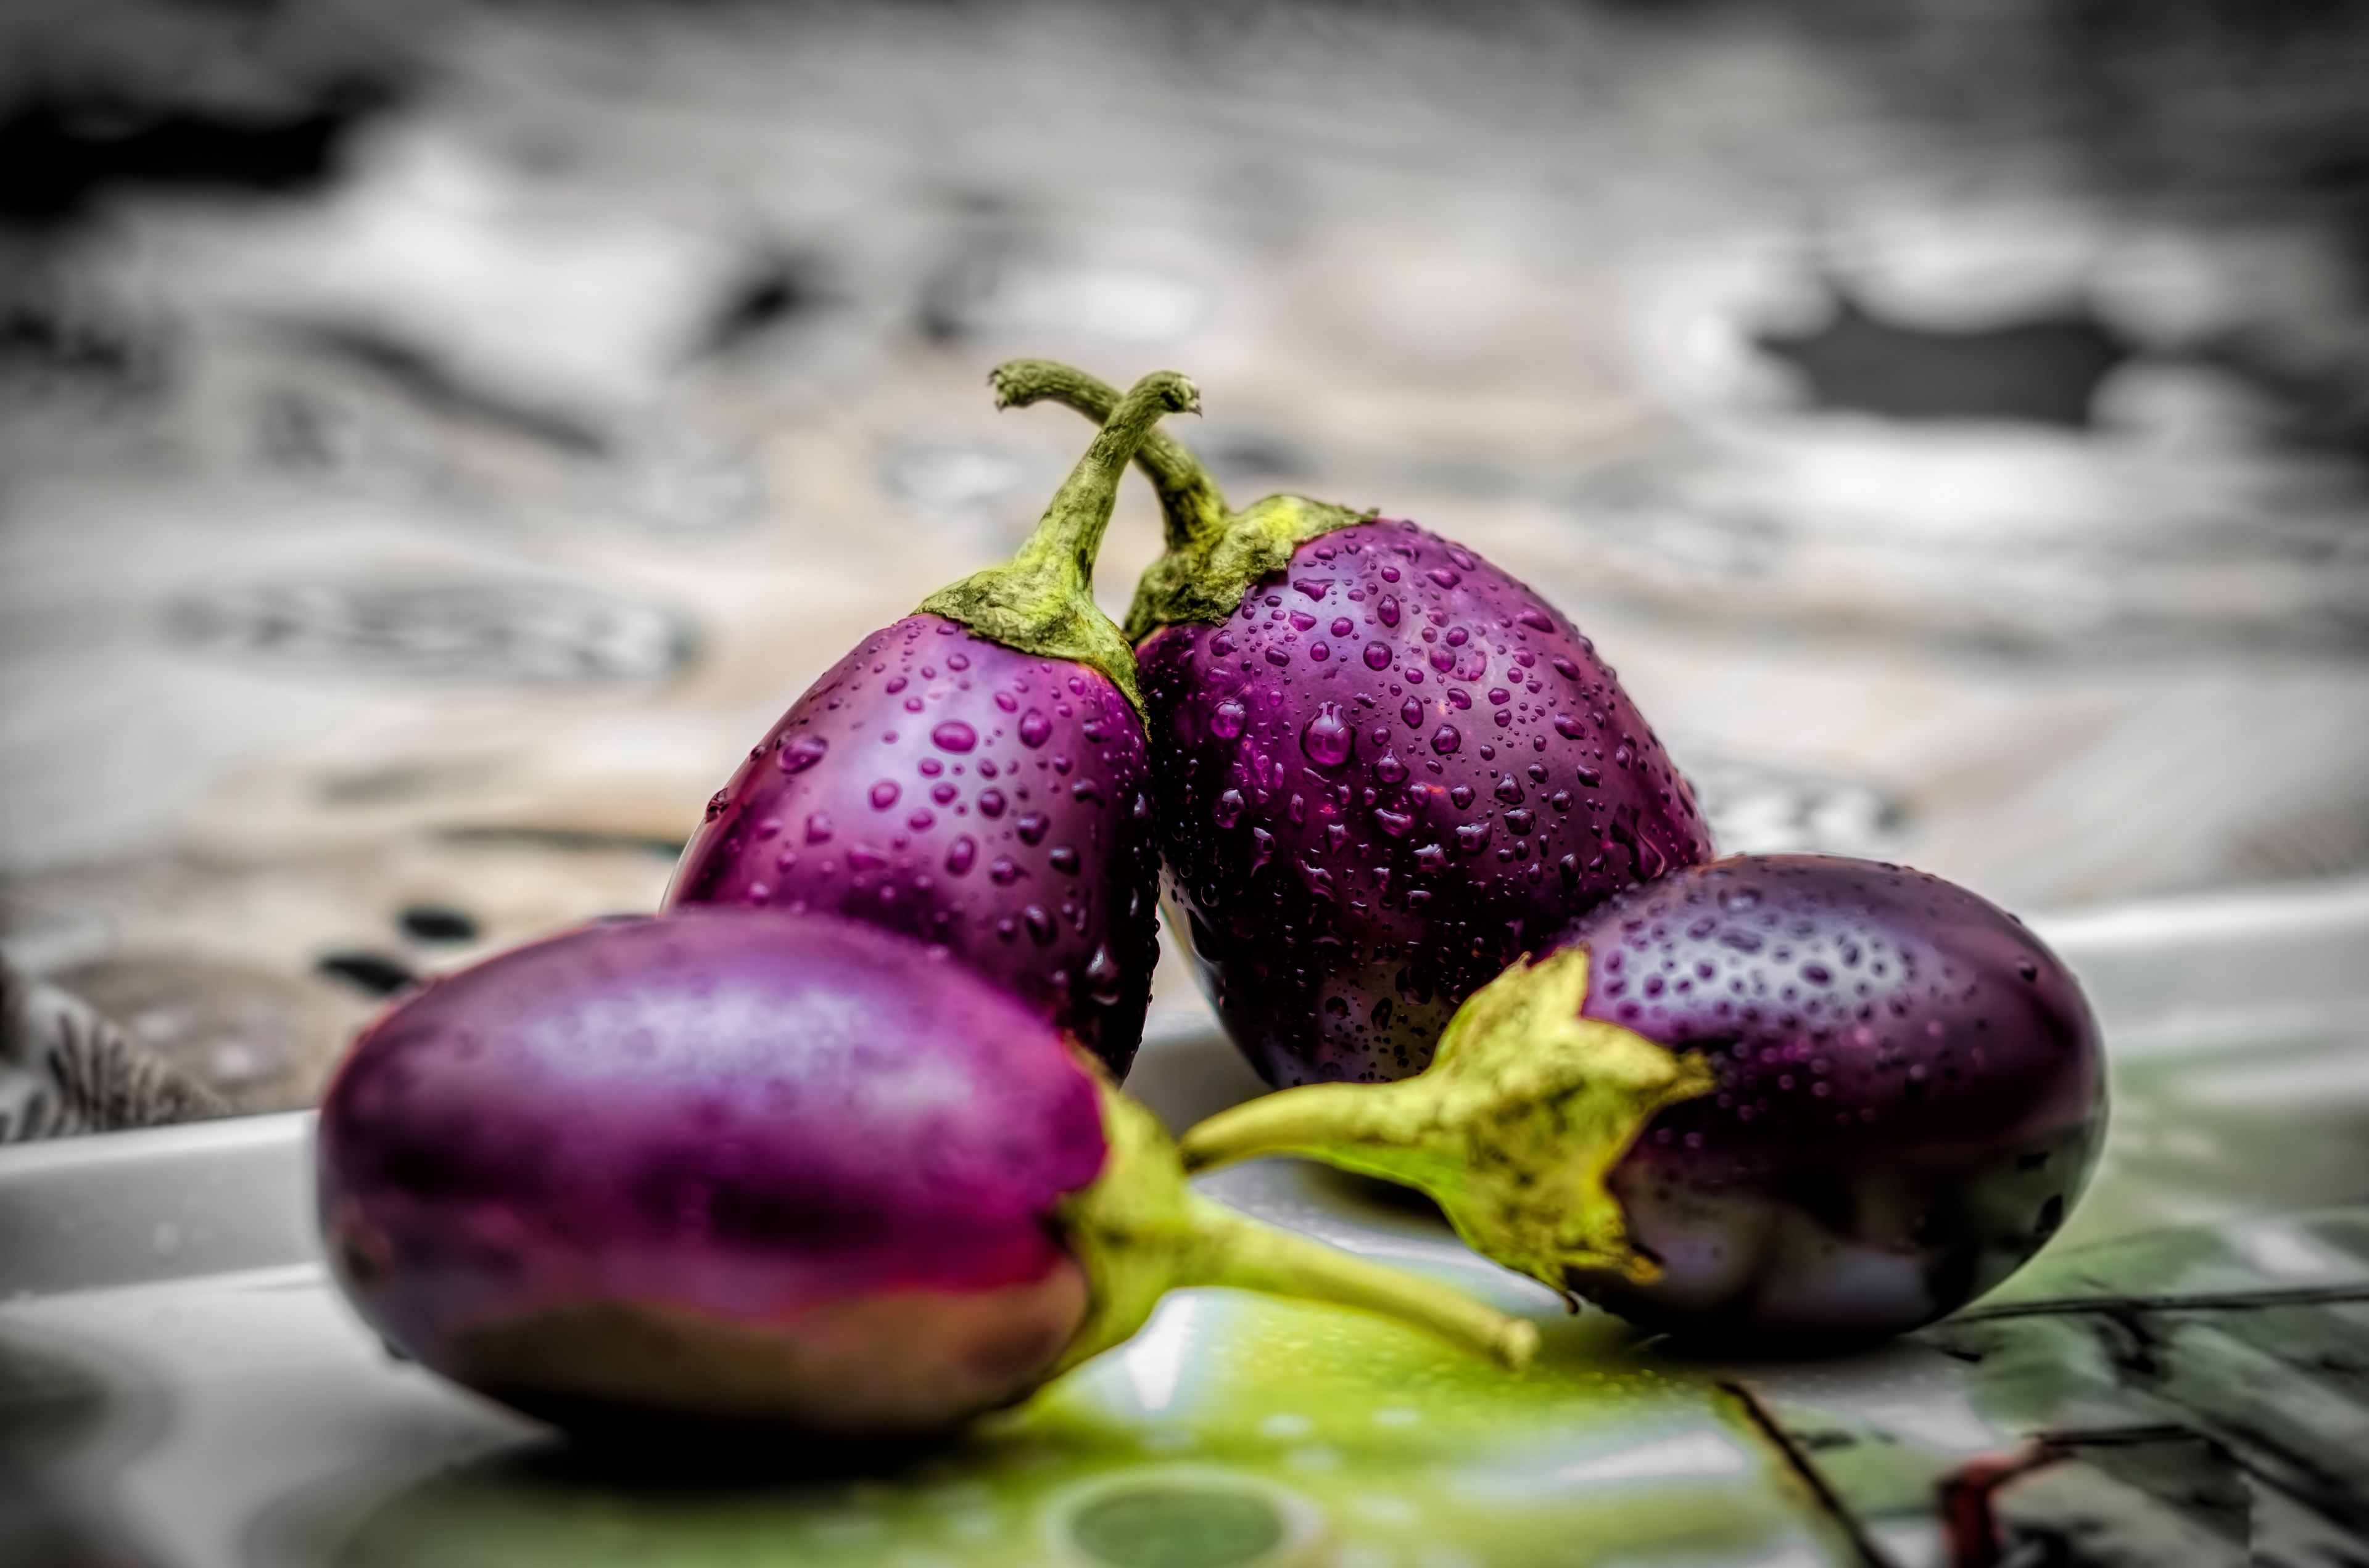





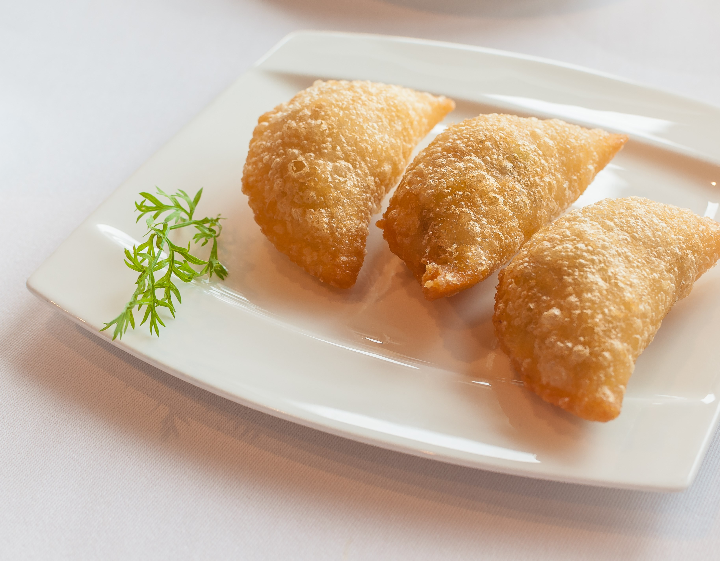

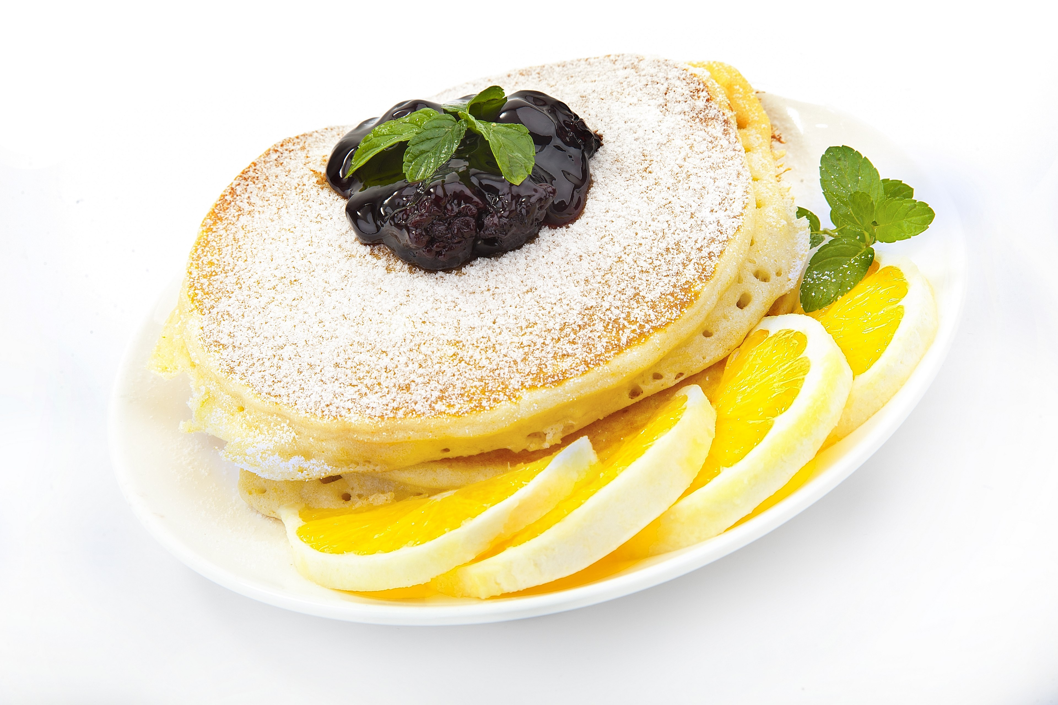

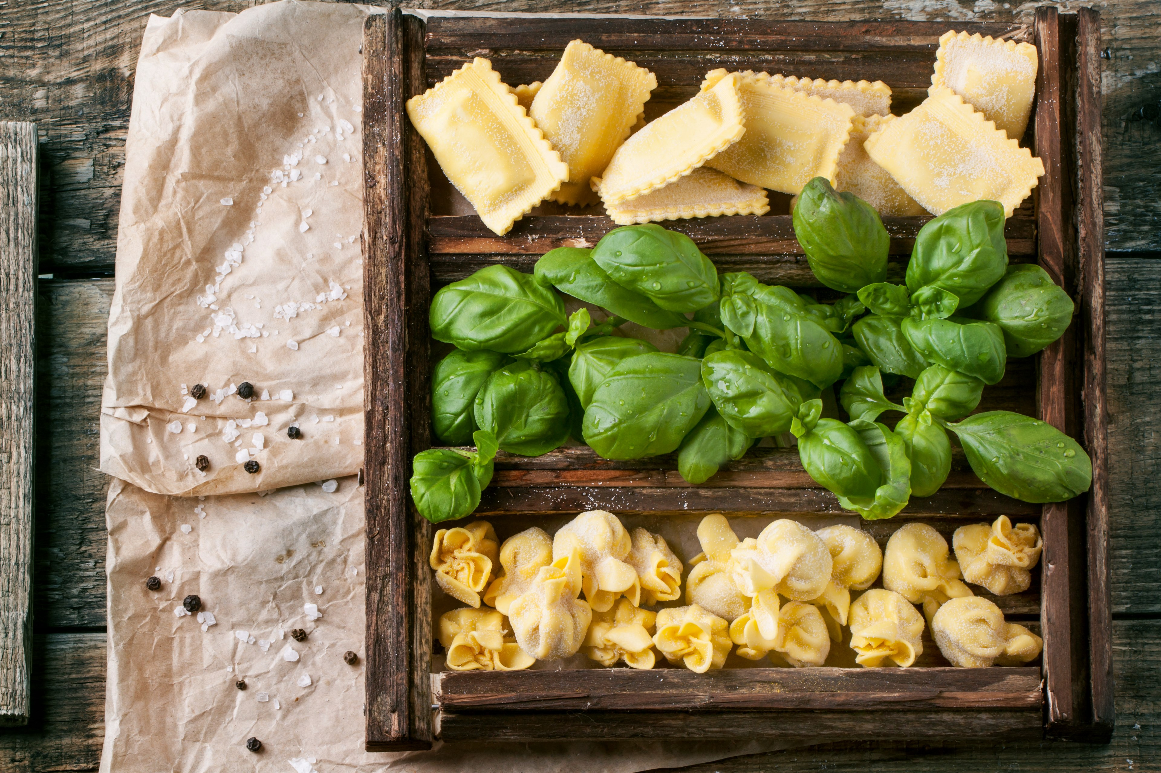

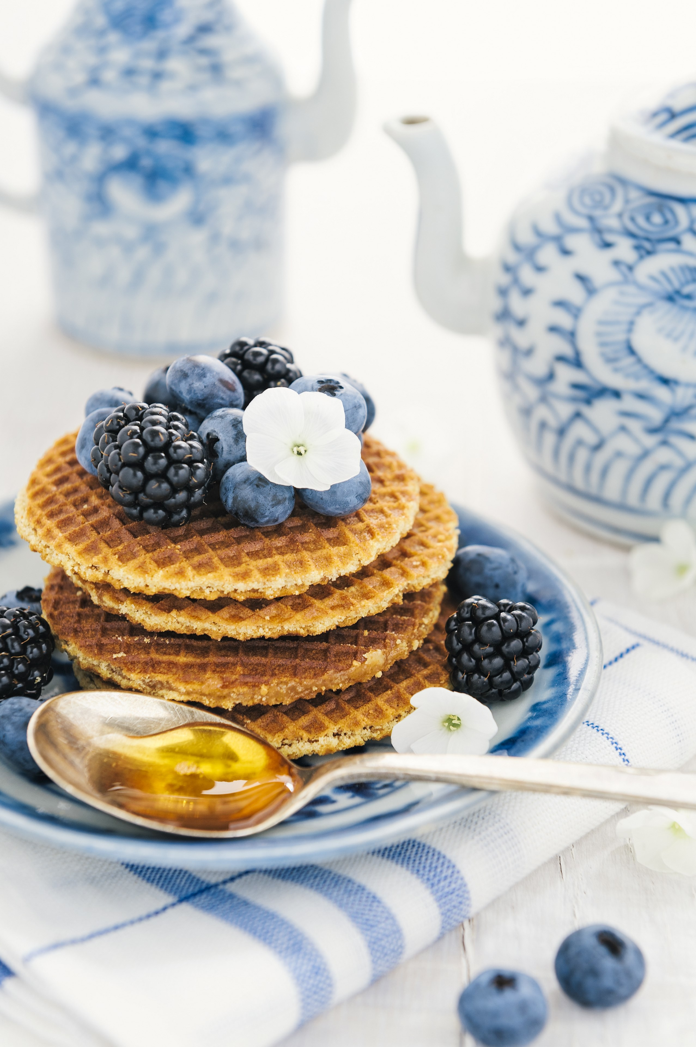



Sway provides an engaging way to showcase your photography, art, or design portfolio. Add your multimedia content, organize it, and you're almost done! Add words where you'd like to provide more context. Emphasize the most important images to focus the reader's attention.

Sway's design engine takes the hard work out of formatting your content by producing professional designs in minutes, auto-aligning and cropping content as needed. Try changing the look and feel of your Sway by clicking on the **Design** tab in the top toolbar. To change the overall layout of your Sway choose a different option.

Sway offers a variety of ways to present your content.  The images in this section are emphasized (subtle, moderate, or intense) to produce different layouts.  Experiment with different combinations of order and emphasis to change the look and focus.

Text in Sway works like regular text, but with a twist. As you type, Sway's design engine generates attractive, professional-looking styling that blends well with your multimedia content. You can use **Emphasis** or Accent to differentiate how different parts of your text look. Emphasis makes text noticeably stand out. Accent is more subtle, but provides similar visual impact. You can also add bullets, numbered lists, and web links.

<http://twitter.com/statuses/674216105481789440>

Sway provides an engaging way to showcase your photography, art, or design portfolio. Add your multimedia content, organize it, and you're almost done! Add words where you'd like to provide more context. Emphasize the most important images to focus the reader's attention.

Sway's design engine takes the hard work out of formatting your content by producing professional designs in minutes, auto-aligning and cropping content as needed. Try changing the look and feel of your Sway by clicking on the **Design** tab in the top toolbar. To change the overall layout of your Sway choose a different option.

Sway offers a variety of ways to present your content.  The images in this section are emphasized (subtle, moderate, or intense) to produce different layouts.  Experiment with different combinations of order and emphasis to change the look and focus.

Text in Sway works like regular text, but with a twist. As you type, Sway’s built-in design engine works to combine your text with other multimedia content and deliver great results. You can use **Emphasis** or Accent to differentiate how different parts of your text look. Emphasis makes text noticeably stand out. Accent is more subtle, but provides similar visual impact. You can also add bullets, numbered lists, and web links.